DBC057D1BSS – 5.7 cu. ft. Built-In Beverage Center Danby No Logo  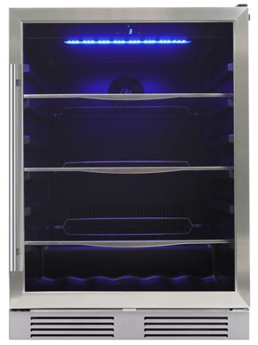 | - 126 max can capacity  - 3 glass shelves trimmed with stainless steel look plastic​  - Stainless steel door frame with towel bar handle  - Stainless steel kickplate​  - LED lights at top of unit with 4 different modes included​  - Temperature range: 37°F -64°F (3-18°C) and 42dB noise level  - Digital thermostat includes temperature, recall function and door ajar alarm​  - Reversible door swing can be set for left- or right-hand opening  - 1-year Parts and Warranty – In Home  - MAP: $ 799.99
DWC057D1BSS – 5.7 cu. ft. Built-In Wine Center Danby No Logo  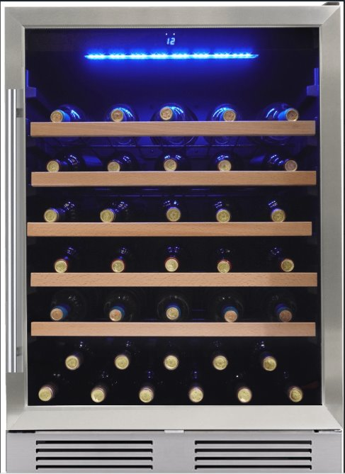 | - Stores up to 63 bottles standard Bordeaux bottles  - 5 wire shelves​ with wooden shelf trim  - Stainless steel door frame with towel bar handle​  - Stainless steel kickplate  - LED lights at top of unit with 4 different modes included​  - Single zone Temperature range: 41°F -64°F and 42dB noise level  - Digital thermostat includes temperature, recall function and door ajar alarm​  - Reversible door swing can be set for left- or right-hand opening  - 1-year Parts and Warranty – In Home  - MAP: $ 799.99

The new line of no logo wine & beverage centers from Danby have now arrived. Please check out these full featured, high-quality, low-cost options that can pair with any brand appliance package. Please contact your sales representative mgiordano@danby.com for more information and display packages available for these and other great wine and beverage centers from Danby/Silhouette.

